**CLOUD COMPUTING**

**NAME: KALAI VARSHAA**

**ROLL: 727721EUIT064**

**Q1. Create an EC2 Instance in the us-east-1 region with the following requirements.**

**Give the Name tag of both EC2 instance & keypair as "ec2usecase1"(Name).**

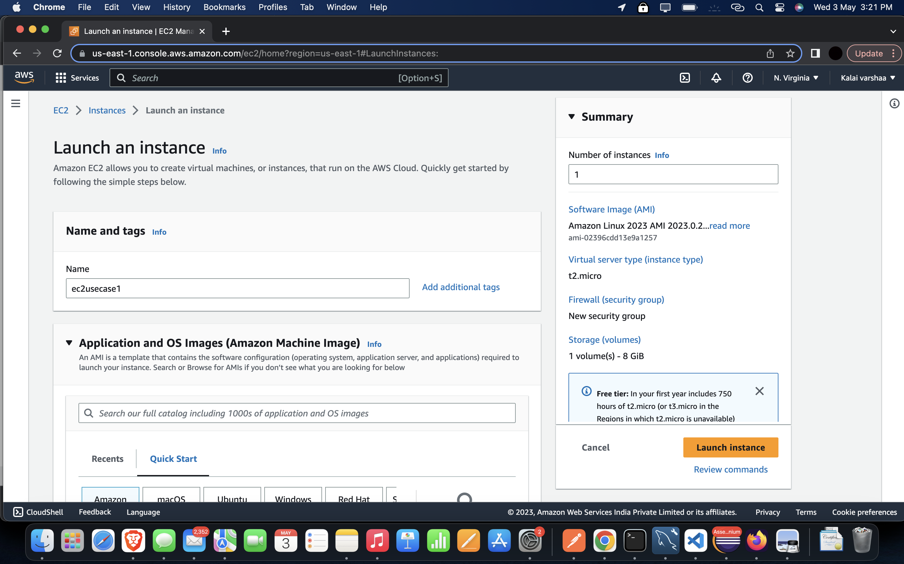

EC2 instance AMI should be "Amazon Linux 2".(4 Marks)

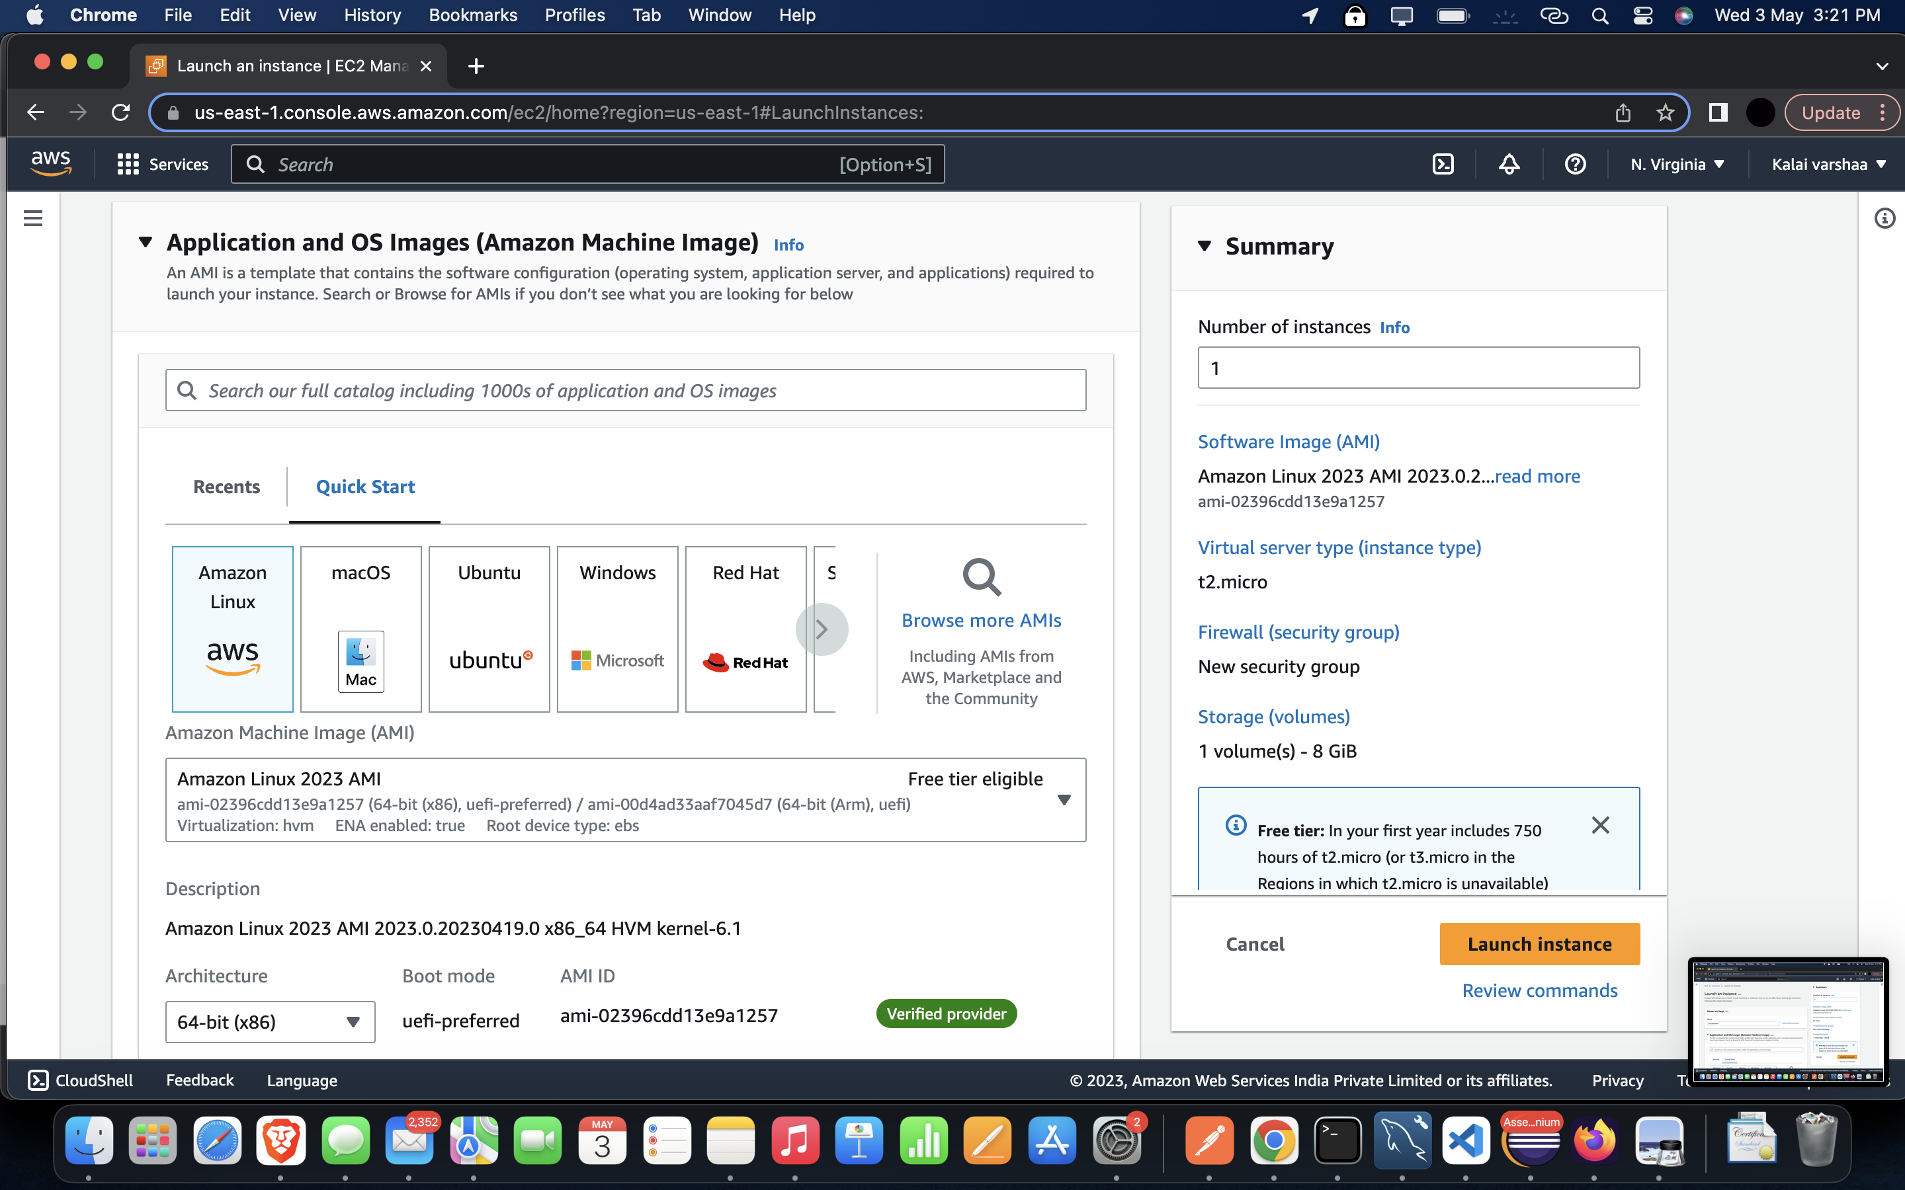

Give the Name tag of both EC2 instance & keypair as "ec2usecase1"(Name).

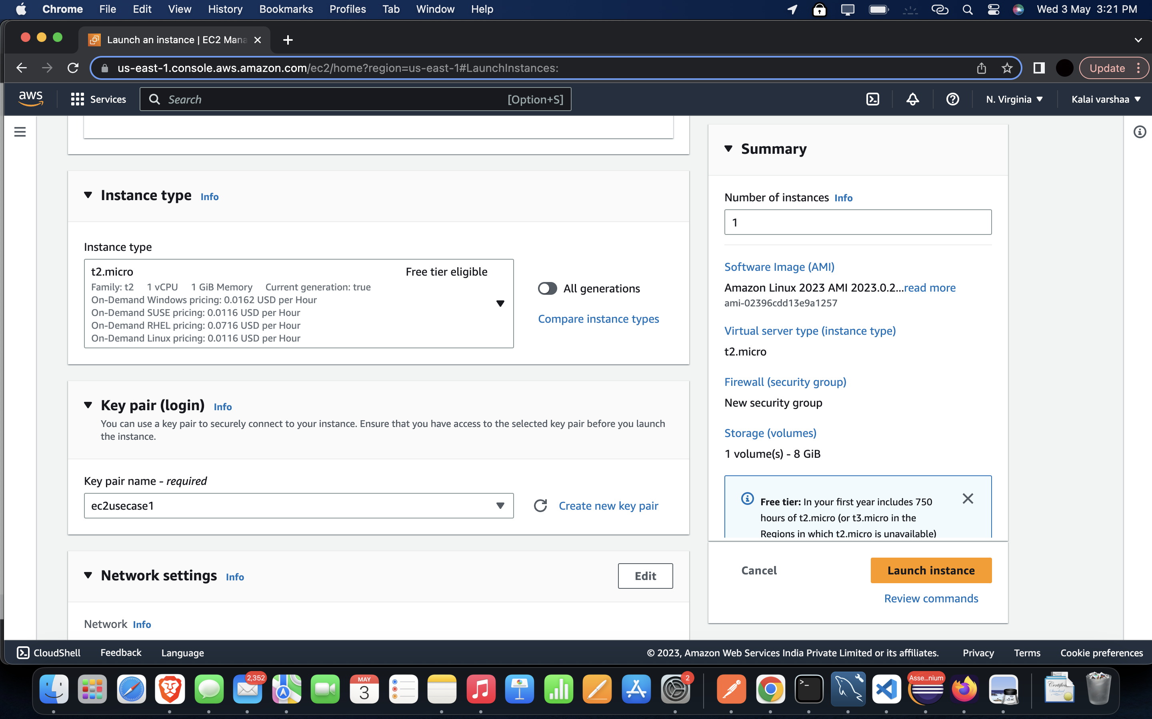

Allow SSH traffic for taking puttyremote connection.(4 Marks)Allow HTTP traffic from the internet for reaching website requests.(4 Marks

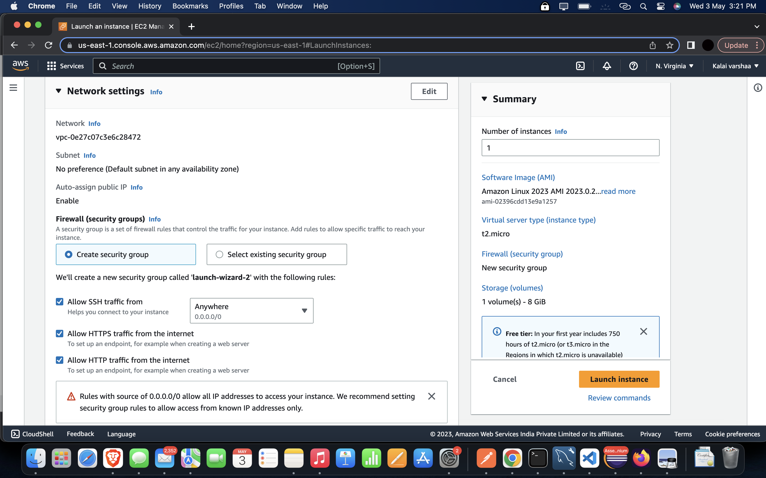

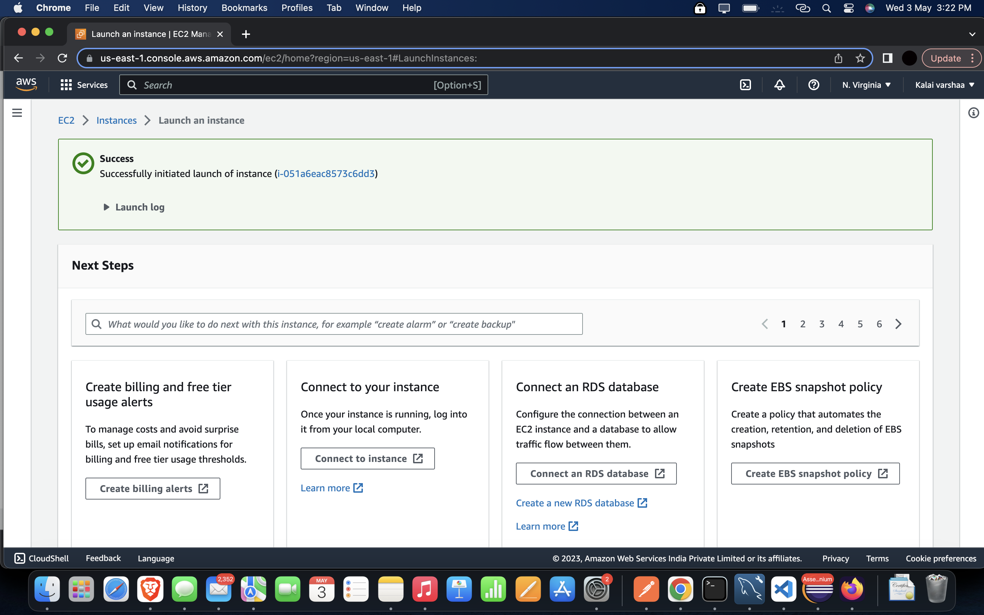

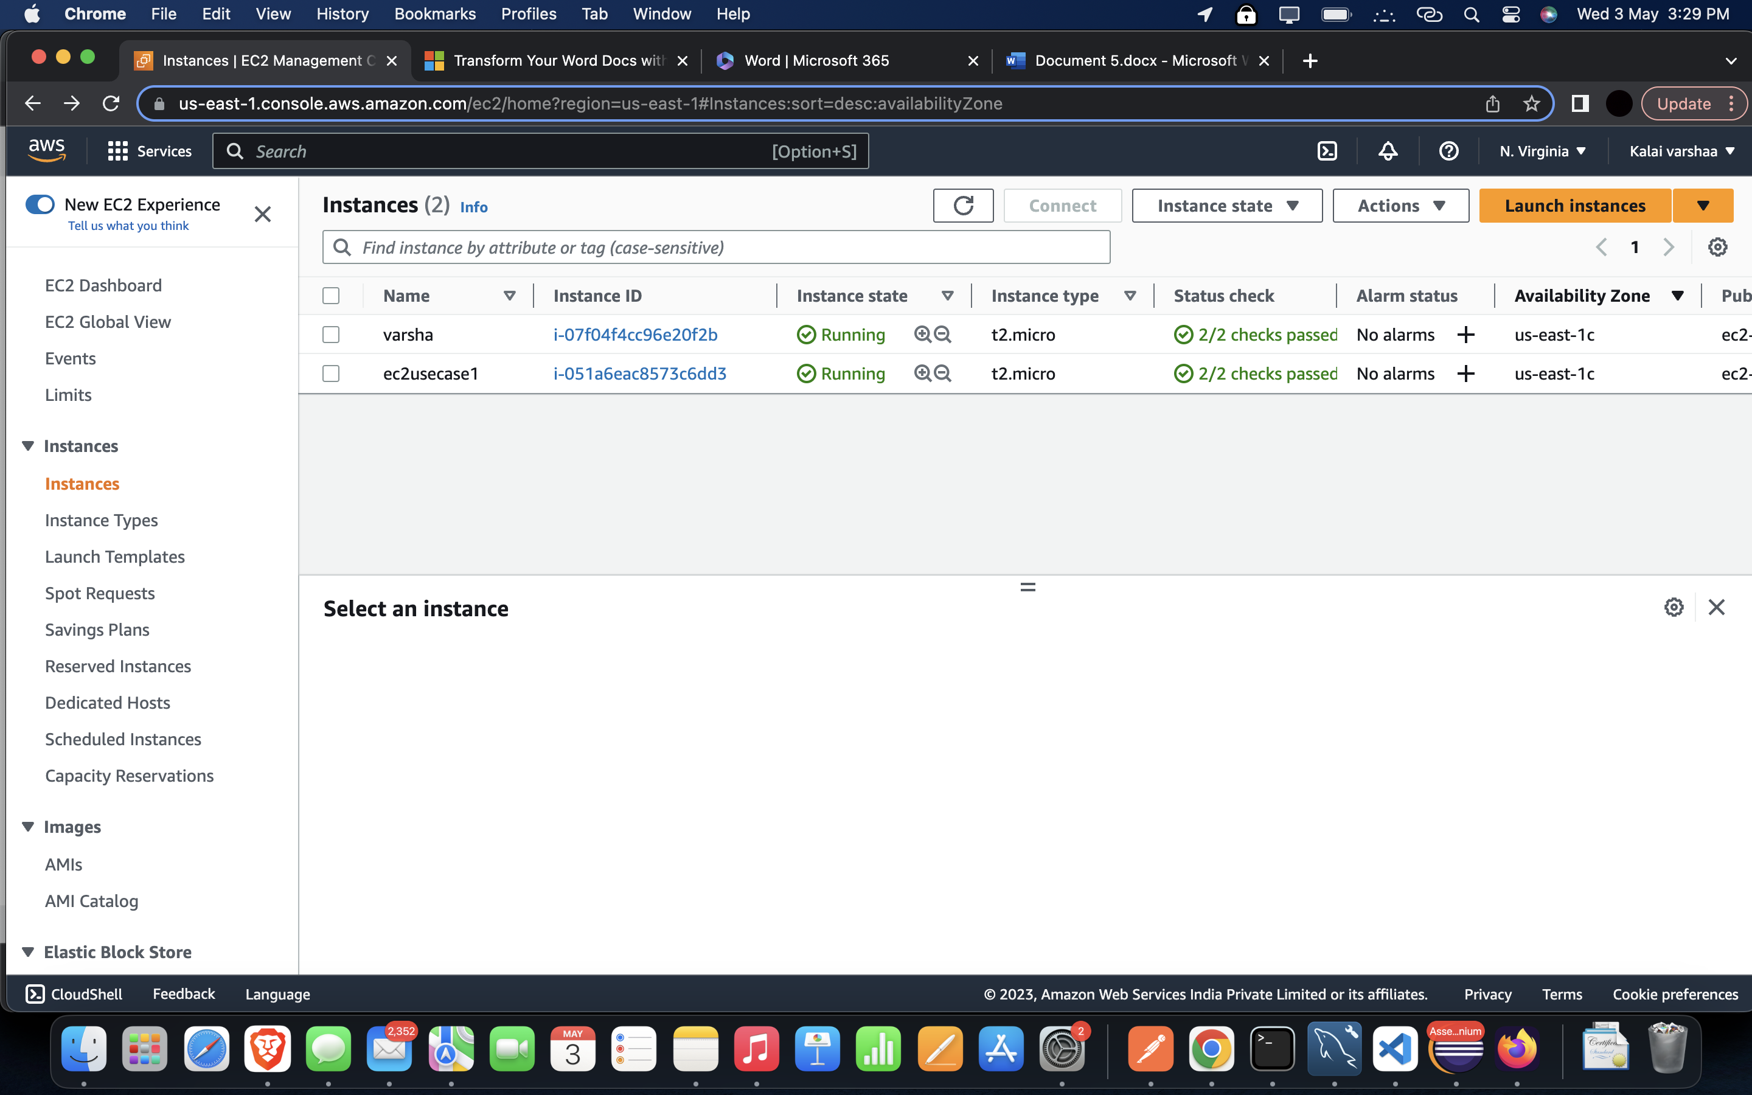

Q2. Create an IAM group called 'Network-L1-Team' with'AmazonVPCReadOnlyAccess'and ‘AWSNetworkManagerReadOnlyAccess' policies, then add an IAM user called 'Network-L1-User1' to the group.The name of the IAM group should be 'Network-L1-Team'.(4 Marks)The name of the IAM user should be 'Network-L1-User1'.(4 Marks)The 'AmazonVPCReadOnlyAccess' policy should be attached.(4 Marks)The 'AWSNetworkManagerReadOnlyAccess' policy should be attached.(5Marks)

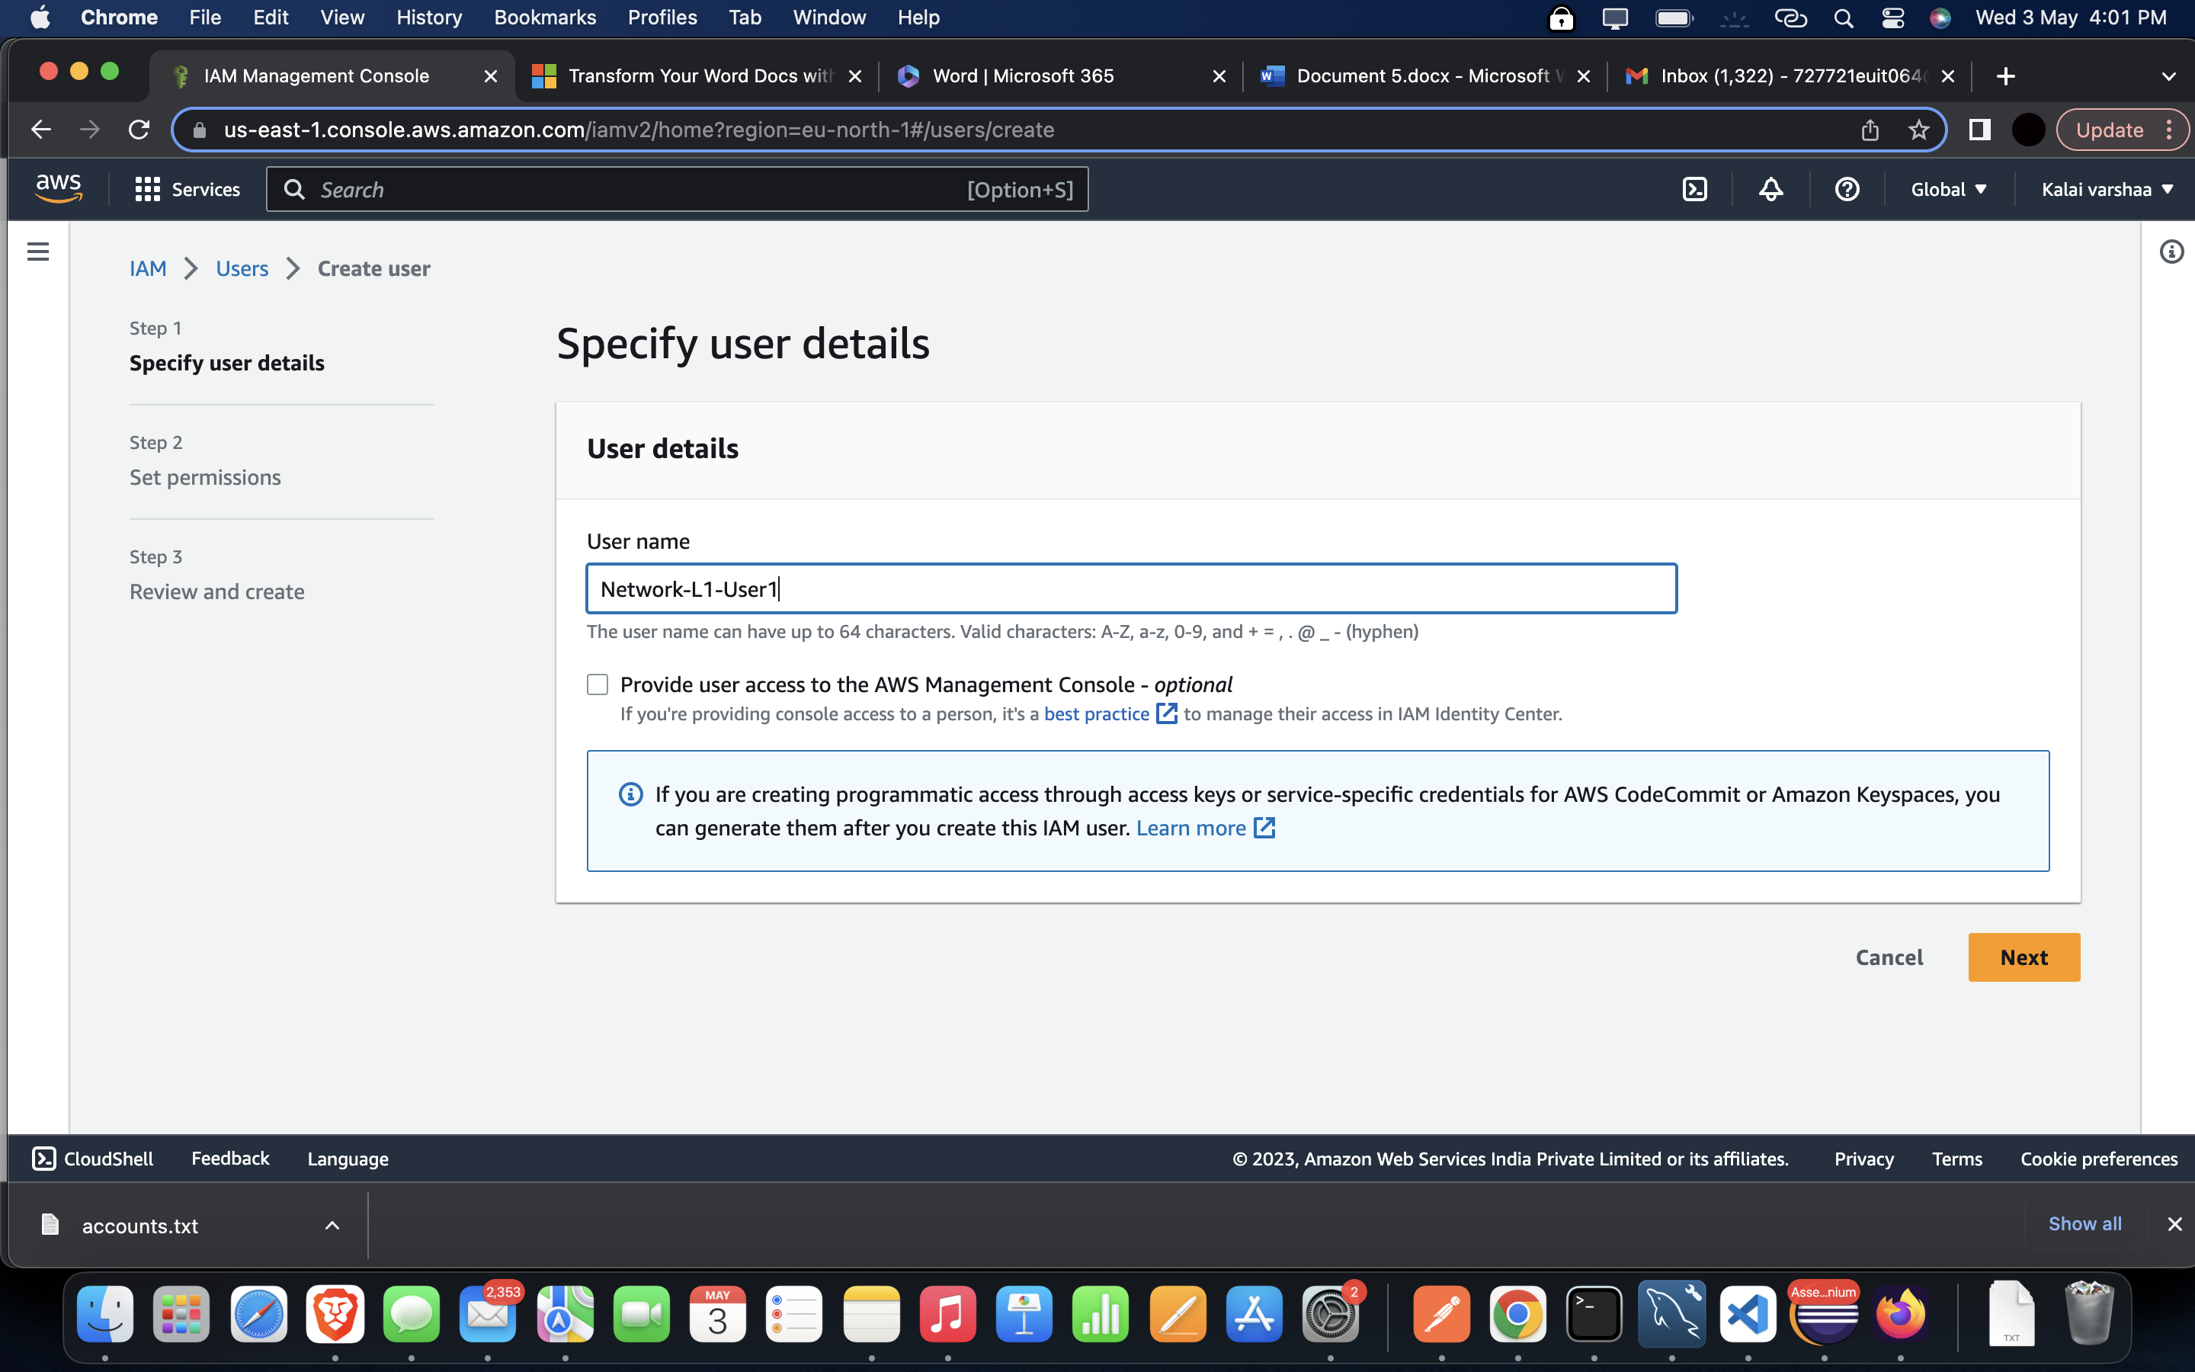

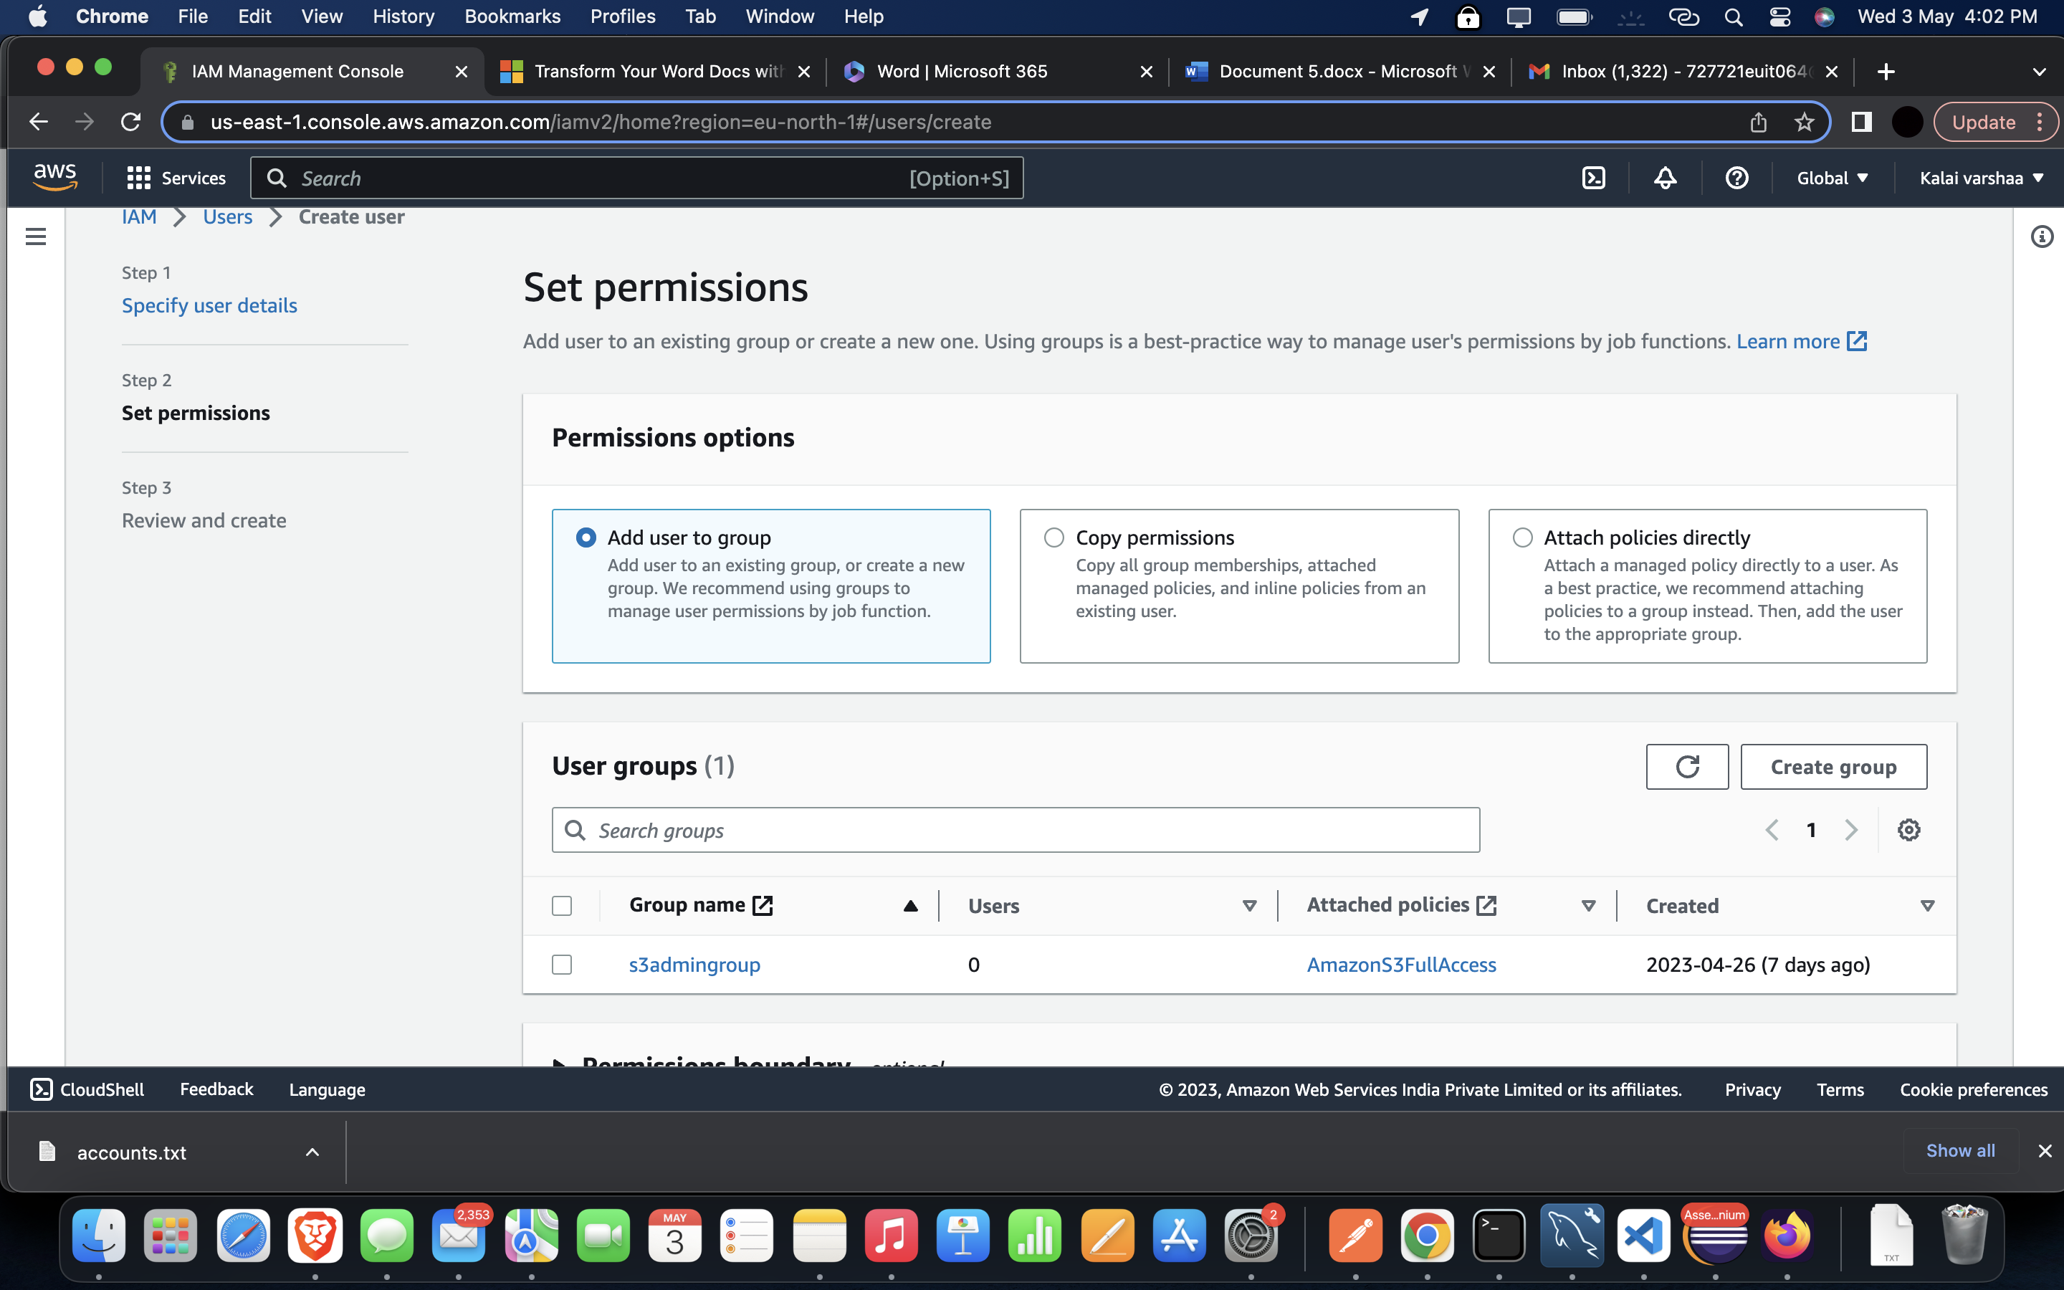

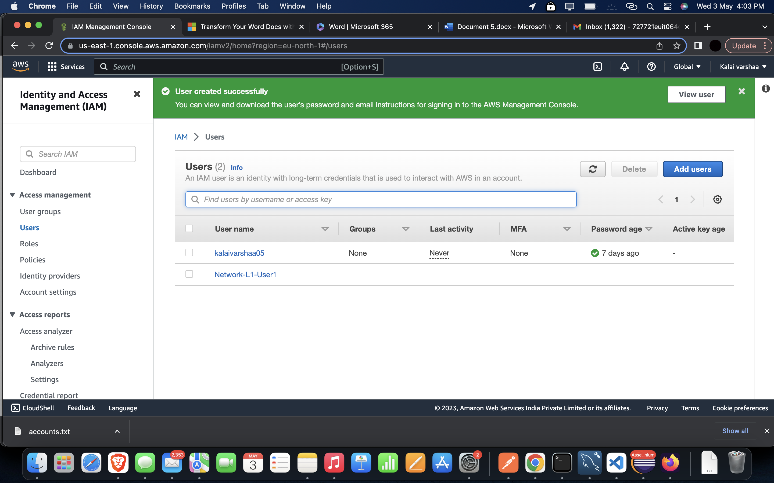

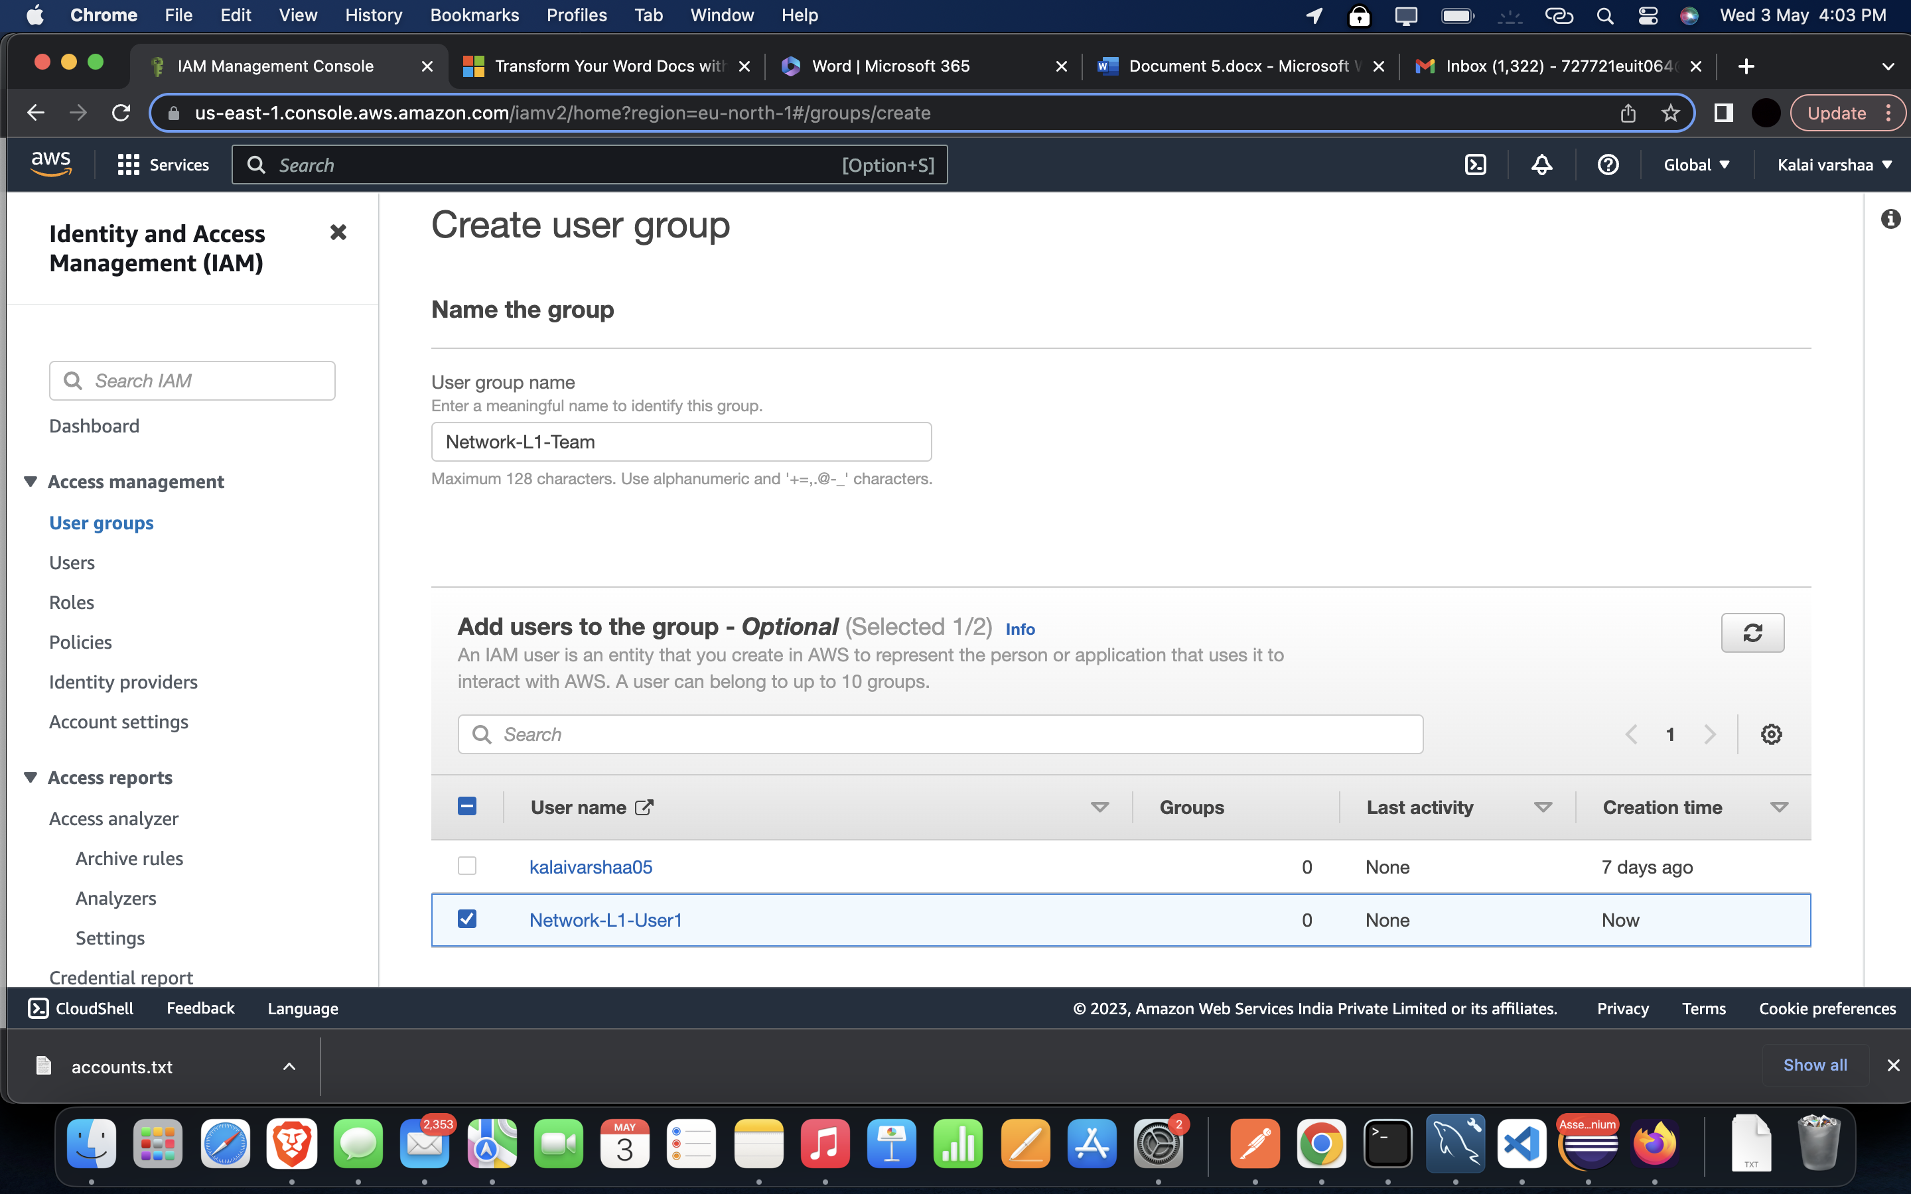

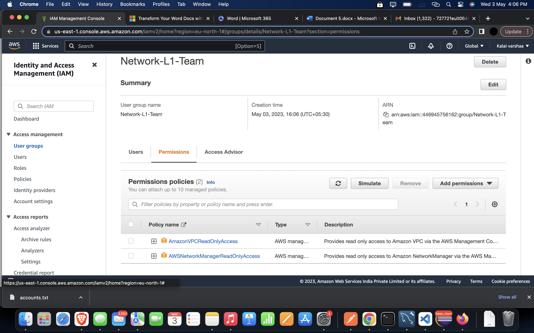

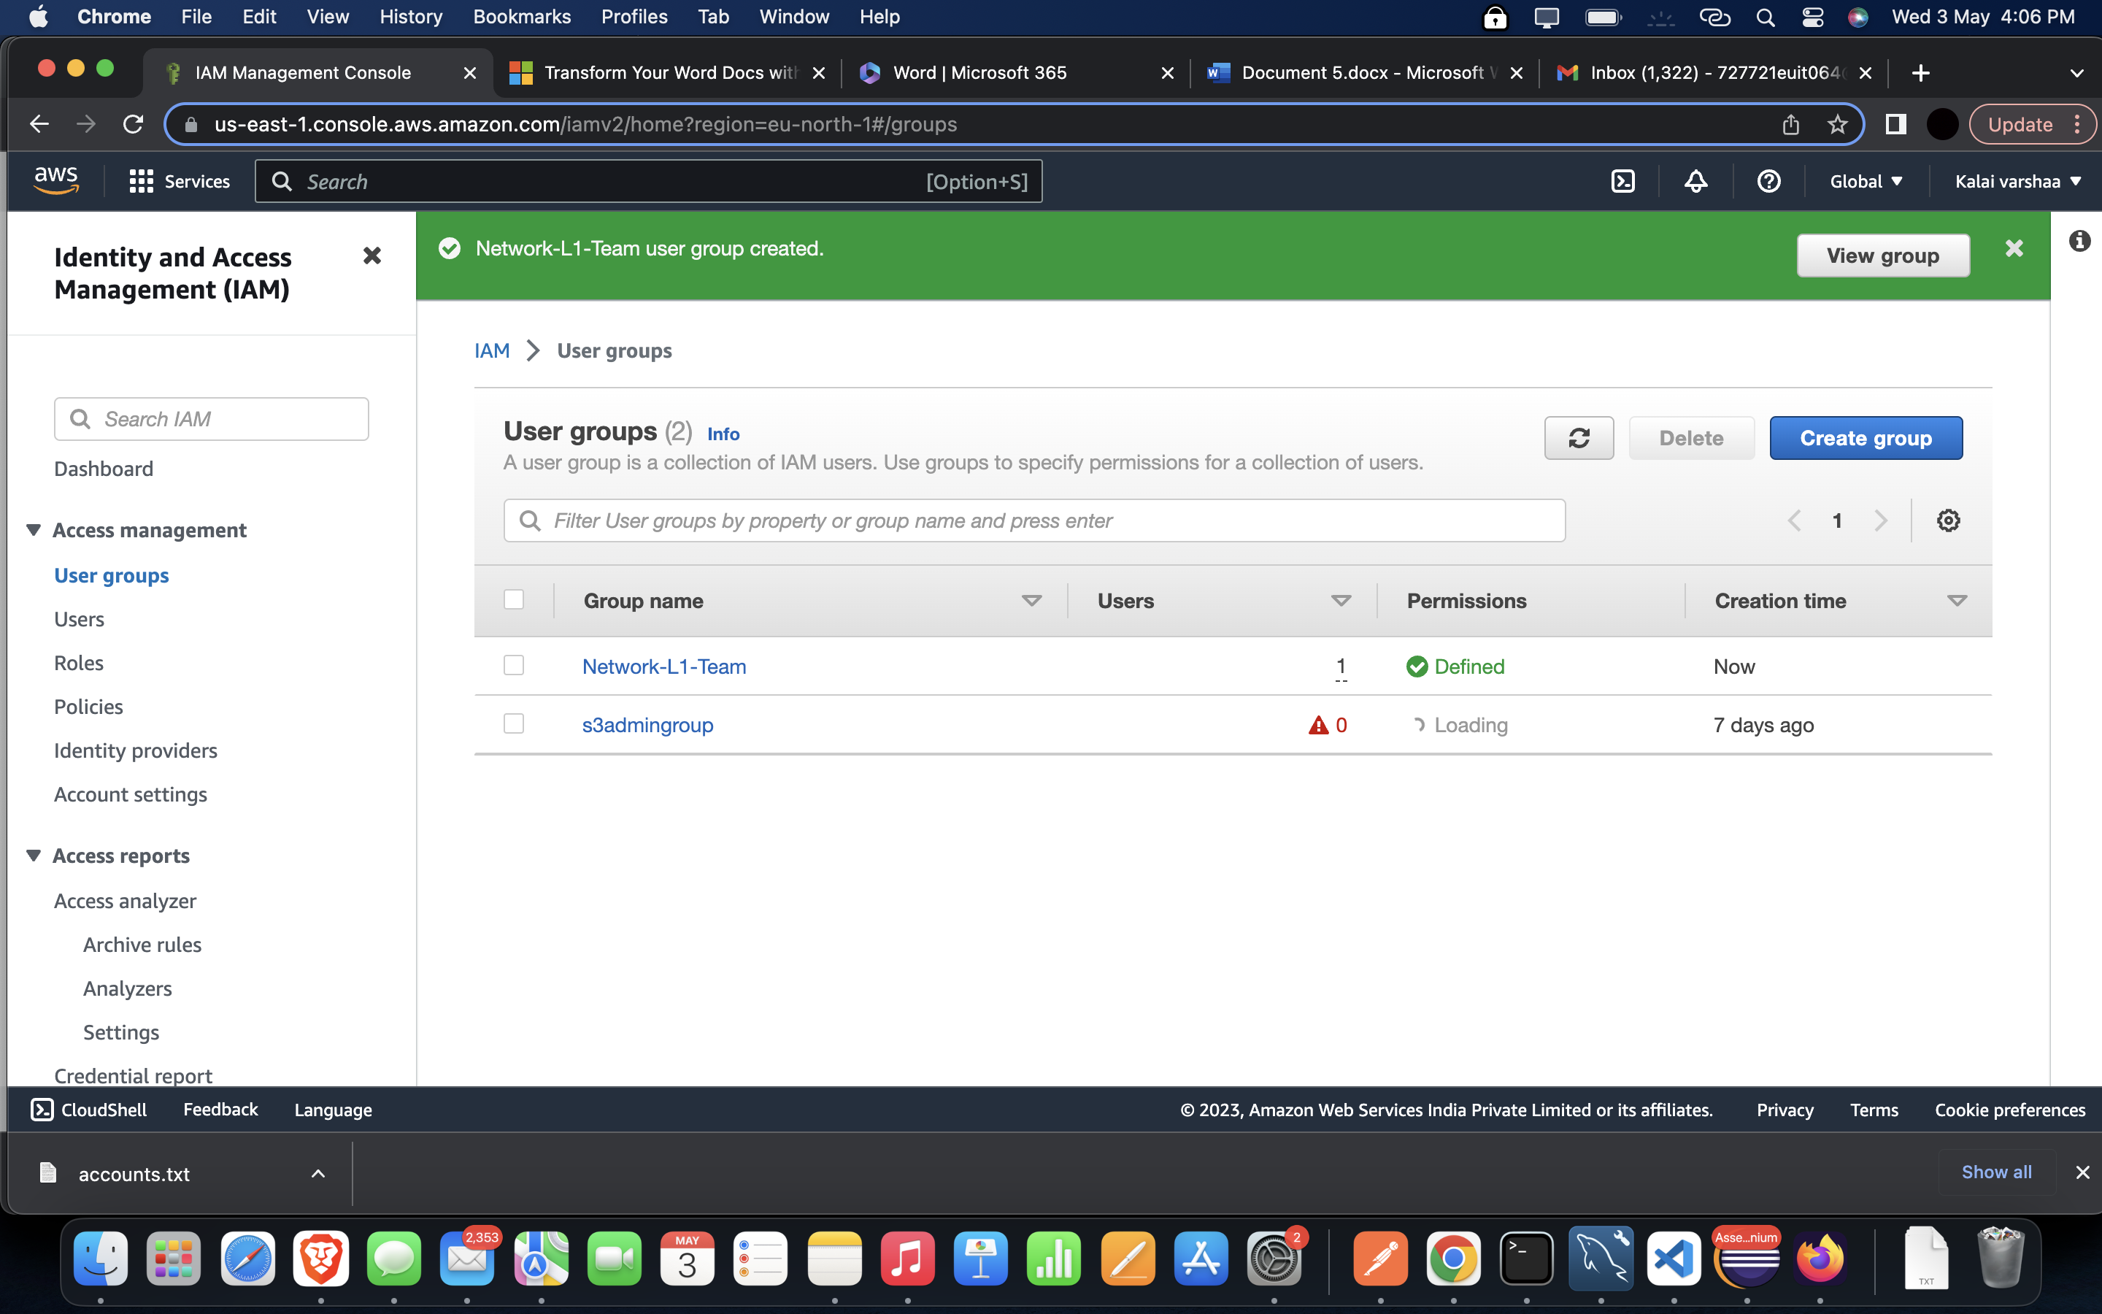

3] Q3. Create a S3 bucket for the following requirementsCreate a new S3 bucket in the region of "Stockholm".(4 Marks)Make the bucket accessible to everyone(publicly) via Bucket ACL.(4 Marks)Upload a text file in the name of 'accounts.txt'. (5Marks)Make the object 'accounts.txt' file accessible to everyone(publicly).(4 Marks)

